
ADAMA SCIENCE AND TECHNOLOGY UNIVERSITY
SCHOOL OF ELECTRICAL ENGINEERING AND COMPUTING
COMPUTER SCIENCE AND ENGINEERING DEPARTMENT

FUNDAMENTALS OF SOFTWARE ENGINEERING (CSE3205)
SEMESTER PROJECT

WEB BASED RENTAL HOUSE MANAGMENT SYSTEM FOR ADDIS ABABA

GROUP MEMBERS ID
- Ashebir Wondemeneh UGR/16809/11
- Yohannes Teferi UGR/17833/11
- Bekalu Jegnaw UGR/16839/11

Submitted to – Yordanos Gebeyehu (MSc.)
Submission date – April 5, 2021

Table of Contents
Acknowledgment v
List of Acronyms vi
1 CHAPTER 1: INTRODUCTION 1
1.1 Introduction 1
1.2 Background 1
1.3 Statement of the problem 3
1.4 Project objectives 3
1.4.1 General objective 3
1.4.2 Specific objectives 3
1.5 Feasibility 4
1.5.1 Technical feasibility 4
1.5.2 Operational feasibility 4
1.5.3 Economical feasibility 5
1.6 Scope and Limitation 6
1.6.1 Scope 6
1.6.2 Limitation 6
1.7 Significance of the project 6
1.8 Methodology 7
1.8.1 Data Source 7
1.8.2 Development Tools 7
1.9 Task and Schedule 9
2 CHAPTER 2 10
DESCRIPTION OF THE EXISTING SYSTEM 10
2.1 Users of the current system 10
2.2 Drawback of the current system 10
2.3 Software Process Models 10
2.4 Waterfall Model 11
3 CHAPTER 3 12
PROPOSED SYSTEM 12
3.1 Overview 12
3.2 Functional Requirement 12
3.3 Non Functional Requirement 12
3.4 Actor identification 14
3.5 System modeling 15
3.5.1 Scenario 15
3.6 Use case models 21
3.7 Use case description 22
3.8 Class Diagram 30
3.9 Dynamic Model 31
3.9.1 Sequence Diagram 31
3.10 Activity Diagram 38
3.11 State Diagram 45
State diagram describes the behavior of a single object in response to a serious of events in a system 45
4 Chapter Four: System Design 51
4.1 Overview 51
4.1.1 Purpose of the system 51
4.1.2 Design Goal 51
4.2 Proposed system 52
4.2.1 Overview 52
Reference 67

List of Figures
Figure 1 Use case diagram 21
Figure 2 Class Diagram for HRMS 30
Figure 3 Sequence diagram for Registration 31
Figure 4 Sequence diagram for Login 32
Figure 5 Sequence diagram for View Notification 32
Figure 6 Sequence diagram for Apply rent 33
Figure 7 Sequence diagram for Fill House Status 34
Figure 8 Sequence diagram for Announce 35
Figure 9 Sequence diagram for Manage Account 36
Figure 10 Sequence diagram for Post homes 37
Figure 11 Activity diagram for registration 38
Figure 12 Activity diagram for login 39
Figure 13 Activity diagram for Apply rent 40
Figure 14 Activity diagram for View notification 41
Figure 15Activity diagram for Fill home status 42
Figure 16 Activity diagram for Announce/Notify 43
Figure 17 Activity diagram for Post homes 44
Figure 18 State diagram for Registration 45
Figure 19 State diagram for Login 46
Figure 20 State diagram for Apply rent 47
Figure 21 State diagram for View notification 48
Figure 22 State diagram for Fill home status 49
Figure 23 State diagram for Post homes 50
Figure 24 Overall RHMS service 53
Figure 25 Overall system of the service 53
Figure 26 System process 54
Figure 27 Subsystem decomposition 54
Figure 28 Class to relational database mapping 56
Figure 29 Tennant mapping 56
Figure 30 Owner mapping 57
Figure 31 Status mapping 57
Figure 32 Register mapping 58
Figure 33 Login mapping 58
Figure 34 Notification mapping 59
Figure 35 Post mapping 59
Figure 35 User interface design of RHMS 64

Acknowledgment

We would like to express our deepest gratitude to our advisor, instructor Mrs. Yordanos Gebeyehu, for her outstanding leadership, support, encouragement, and guidance through the project.

List of Acronyms

HTML5 - Hypertext Markup Language
PC - Personal Computer
PHP - Hypertext Pre Processor
RAM - Random Access Memory
RHMS - Rental House Management System
UML - Unified Modelling Language ·
SRS –Software requirement system

CHAPTER 1: INTRODUCTION

Introduction
We are weighted with technology when what we genuinely want is just shift that works with the modern paradigm shift in technological field, there is an instant need to embrace and appreciate the power of technology. House sector remains alert to face the challenges of change by employing a new system that facilitates easy management of rental houses. Rental house management has become important factor in modern society hence the need to have a rental house management system.
The Rental house System is searching in Based on the Apartment House for rent in metropolitan cities. The House Rental System is based on the Owners and the Customers. The Owner is updated on the Apartment details, and rent details. The Customer is details about the Room space, Room rent and the address Details also. The Rental House System is best suitable the owners because time save and the only contact and the eligible person and there is no need to explain the room details on the speak. The Rental House System is best application in the city place. The customer contact and the easily search and the suitable place of House and based the Money, Limit Person is based on the suitable house. The Rental Home System is save the time also. The Rental Management System is used to easily identify the suitable place in save time, cost also. Hence this system is best applicable for the above reasons making House rental an easy process through an online system.

Background
This project mainly focuses on connecting house owner and tenant. Housing has a central importance to quality of life with considerable economic, social, cultural and personal significance. Though a country’s national prosperity is usually measured in economic terms, increasing wealth is of diminished value unless all can share its benefits and if the growing wealth is not used to redress growing social deficiencies, one of which is housing (Erguden, 2001). Housing takes a massive part in renewing economic growth in any country, with shelter being among key indicators of development.
The universal declaration of human rights gives one of the basic human rights as the right to a decent standard of living, central to which is the access to adequate housing (United Nations, The Human Rights-article 25, 1948).
Housing as a basic human right demands that urban dwellers should have access to a decent housing, defined as one that provides a foundation for rather than being a barrier to good physical and mental health, personal development and fulfillment of life objectives (Seedhouse, 1986).
Most families choose to rent houses based on their income and family situations; unfortunately, there may not be enough good quality rental housing for these families. Housing is a major problem in Ethiopia Especially in Addis Ababa city. Millions of people are living in sprawling slams and also in other informal settlements around Addis Abeba. This explains why people have shifted to developing rental houses in Addis Ababa and other parts of the country. The demand for rental house is extremely high and more rental houses need to be put in place.
As the number of tenants tends to increase, the management of the rental houses tend to be difficult since most of them are paper based. Some tenants can use this weakness as a chance to evade paying the rent hence loss to the Owners.
Thus, the focus of this project is to help Owners to manage rental housing they have put in market and to give access to the low-income families to easily find houses-to-let via technology rather than physically searching for rental houses or find brokers who would help them with the process of finding rental houses in which they might incur extra cost. This system will help the landlords to advertise their houses so as they can attain as much tenants as possible which become a source of income.

Statement of the problem
Over the years owners have had a problem in maintaining and managing their customers and their own records.
Management has become difficult because of the issues that include:
- Data growth
- Data increases day to day. Storing and maintaining all data manually is very difficult
- Lack of computerized system
- Currently most owners use system in recording and maintaining their property and customers data.
- Data security is not assured
- In a manual way, data is recorded on books/papers which may easily get damaged leading to loss of data
- There is no database to store information
- Potential of data loss or damage is very high because data is stored on tangible files.
- Lack of these crucial requirements makes management of the tenants and houses very difficult as some tenants may end up not paying rent.

Project objectives

General objective
The main objective of this project is to design and implement a system that can be accessed on portable devices such as mobile phones, that will digitalize the manual house rental management system and thus helping the owner to manage the house and tenants’ information and the tenants to have a digital way to access the information about the house and the time to stay in the house per amount paid for accommodation. With addition of further studies this project will cover broad areas in the future, and it will include more additional features like payment, contract deals, renew contract deal, and repost home after contract deal is off.

Specific objectives
The following are the project objectives:
- To reach a significant number of owner and tenants digitally offering a platform to easily manage their houses and have access to the rental houses respectively by the end of the contract.
- Deliver light weight web application platform.
- Reducing the time and money waste by making the system accessible online.
- Increasing the owners and tenants satisfaction

Feasibility
Now, we will carry out a study to gain an understanding of the tenants’ current system and problems experienced in this obtained system through interviews, observations, and participations We will use the data to determine the viability of the system being proposed in terms of technical, economic and social feasibility.

Technical feasibility
In technical feasibility the following issues are taken into consideration
- Whether the required technology is available or not
- Whether the required resources are available like man power, programmer, tester, and software developer etc...
Once the technical feasibility is established, it is important to consider the monetary factors also. Since it might happen that developing a particular system may be technically possible but it may require huge investments and benefits may be less. For evaluating this, economic feasibility of the proposed system is carried out.

Operational feasibility
Operational feasibility is mainly concerned with issues like whether the system will be used if it is developed and implemented. Whether there will be resistance from users that will affect the possible application benefits?
The essential questions that help in testing the operational feasibility of a system are following
- Does management support the project?
- Are the users not happy with current business practices? Will it reduce the time (operation) considerably? If yes, then they will welcome the change and the new system.
- Have the users been involved in the planning and development of the project? Early involvement reduces the probability of resistance towards the new system.
- Will the proposed system really benefit the organization? Does the overall response increase? Will accessibility of information be lost? Will the system affect the customers in considerable way?

Economical feasibility
For any system if the expected benefits equal or exceed the expected costs, the system can be judged to be economically feasible. In economic feasibility, cost benefit analysis is done in which expected costs and benefits are evaluated. Economic analysis is used for evaluating the effectiveness of the proposed system.
No | Cost Type |  | Quantity | Unit Price(ETB) |  | Total Price(ETB)
1. | Personal Computer  - HP-ProBook  - Intel® Core™ i5  - Core Processor(2.60GH)  - 4BG RAM  - 14” |  | 1 | 15000 |  | 15000
2. | Windows 10 Pro |  | 1 | 8239.18 |  | 8239.18
3. | Stationary | - Pen | 2 | 6 |  | 12
3. | Stationary | - Pepper | 20 | .50 |  | 10
4. | Flash(16GB) |  | 1 | 250 |  | 250
5. | Mobile card |  | 4 | 15 |  | 60
Total |  |  |  |  | 23,571.18

Financial benefits
The website developer will be paid by the owner of the house and the tenants when they access the website. The owner will not pay multiple times to the broker, but if the uses this website it only pays once, access any time and will save time. The tenants save cost, easily manages time and can get their own desired homes.

Scope and Limitation

Scope
- The web-based House Rental Management System project is limited to the design of the system and development of the prototype. That means the project does not procced the implementation, testing and deployment of the whole system.
- The system keeps the record of all registered the owners and tenants.
- The system helps tenants to use their time.

Limitation
- Since it is a Web-based system the service provided by the system it is not reachable by users who don’t have an internet connection.
- Due to the fact that there is shortage of time we couldn’t perform our activities effectively.

Significance of the project
- Tenant can choose their home when ever available and where ever they are.
- The system will notify the tenant when they found their desired homes.
- The system will help the owner and the tenant to reduce cost and save time.
- Reduce paper work.
- The system provides reliability.
- By making renting house online the project will help house owner and company.

Methodology

Data Source
We gathered information from interview, questioner and past experienced of persons like students, teachers and some other professional persons.

Development Tools

Software Tools
No |  | Name | Description
1. | Operating Systems | Windows 10 | Handling computer hardware and providing environment application to run programs
2. | Client side | HTML5 | Hypertext markup language used for web front end
2. | Client side | CSS | Client Side Server used for web front end
2. | Client side | PHP | Hypertext Preprocessor used for back end
3. | Server side | Xampp | Connects the database
4. | Documentation | MS Office word 2010 | Important word processing application
5. | Browser | Microsoft Edge | Open source web browser
6. | Communication | Telegraph 7.6.0 | Share information with project members
7. | Code merger | Sublime | Write multiple programming languages within itself

Hardware Tools
No | Name | Purpose
 | Personal Computer | - Writing documentation  - Surfing  - Coding  - Serving  - Testing  - Nearly all part of the project
 | Printer | - To print documents
 | Flash | - To share files
 | Stationary  - Notebook  - paper  - pen | - To record notes

Team Composition
Title | Rental House Management System
Name | ID No | Email | Roll
Ashebir Wondemeneh | UGR/16809/11 | ashu07wondemeneh@gmail.com | Coordinate and lead the Members, Design, implementation and documentation
Yohannes Teferi | UGR/17833/11 | yohateferi@gmail.com | Requirement Analysis, Documentation
Bekalu Jegnaw | UGR/16839/11 | jeganawbeke@gmail.com | Requirement, Analysis, Documentation

Task and Schedule

Phases | Months
Phases | March 1,2021 - March 12, 2021 | March 13, 2021 - March 21, 2021 | March 22, 2021 - April 1, 2021 | April 1, 2021
Requirement gathering and Analysis
Documentation
Design and Architecture
Implementation
Maintenance

CHAPTER 2

DESCRIPTION OF THE EXISTING SYSTEM
Currently in Addis Ababa house rental management System is fully manual system. It is necessary to know the existing system of a given organization or any other apartment sites to develop a better system. As mentioned above existing system currently performs different activities including registration, management, House seekers and report generation manually.

Users of the current system
- Company
- House seeker’s(tenants)
- House owners

Drawback of the current system
- Currently The system is totally manual
- The manual system is slow then the computerized system.
- It is very time consuming.
- It is very complex system.
- It is required more clerical work and use more man power.
- The current system is not user friendly.
- It takes too much cost to perform procedure.
- It is difficult to store the data

Software Process Models
A software process model is an abstract representation of process. It presents a description of a process from some particular prospection. In this case the methodology we use is waterfall model.

Waterfall Model
It is comprised of the stages that the developer will use when developing the system. It is a sequential (linear) model hence, the name waterfall. The developer has to finish with one stage before going to the next one. It comprises of the feasibility study, analysis phase, design phase, coding phase, testing phase, implementation phase and finally the maintenance phase. It is a simple model and easy to use and understand. With water fall development based methodologies, the analysts and users proceed sequentially from one phase to the next. The deliverables from each phase are voluminous and are presented to the project sponsor for approval as the project
moves from phase to phase. Once the phase is approved by the sponsor it ends and the next phase begins.

CHAPTER 3

PROPOSED SYSTEM

Overview
The proposed system is designed to replace the manual system of house rental management system in to computerized system.in addition it’s used to design to store information about the tenant, owner of the homes and company in the data base for the purpose of reducing the problem faced by manual system.

Functional Requirement
Functional requirement defines a function of a system or it’s component where a function is described as specification of behaviors between out puts and inputs.

The basic functional requirements for our systems are: -
- Users can login and logout to the system.
- Users can create new account.
- Establish a bridge between the RHMS and the user.
- View the numbers of house that are available for rent.
- View address of the house.
- View costs of house.
- View status of houses
- Notify the user if there are available houses for rent.

Non Functional Requirement
They are requirements that specify criteria that can be used to judge the operation of a system, rather than specific behavior’s major nonfunctional requirements of our systems are as follows:

Usability
The system should be easy to learn and understandable for the user. Since system will be developed by considering all house seekers and house owners. it will have a user manual that tells the user how to use the system and we will give enough training for the users on how to operate the system.
Reliability
The system should be highly reliable. Since the user of the system is the tenant and the house owner, the system will be best in handling errors and display an appropriate error message in order to minimize system failures.
Maintainability
The system should be maintainable. Because the interaction between subsystems will be loosely couple and the interaction between classes and operations will be highly cohered, changes made on our system such as adding other functionality shouldn’t affect the existing functionality of the system.
User interface
From each and every page the user can easily go to any desired page. There will be an absolute and relative linking.
- The design or layout of every form will be very clear to the user.
- In the login page the user can easily enter the desired password and username. Then it will give the successful log in message or error message and allow them to try again if either user name or password or both of them are not correct.

Performance consideration
The performance of the System can be seen as aspects of:
- Response time: The system should give the right response for the User as fast as possible since the system we are developing is web-based application or desktop application. So, it will not be sophisticated to use and it will not take much time to handle responses.
- Accuracy: a house rent system is accurate when the tenant gets the house at instant time.
- Scalability: It can work on from individual house to and large community houses like appartement and condominiums.
- Availability: It gives consistently correct results, so User can get information from the system or while the system is done its job clearly.
- Efficiency: HRMS will utilize processor capacity, disk space and memory efficiently.

Actor identification
Actors are the users of the developed system that will support. They can be people, organizations or it might be other sub systems that they directly interact with system.in our system the possible actors are
- Tenant
- Company
- House owner
Name | Description | Role
Tenant | Person that are seeking a house to be rented. | - Fill the profile form and then registered  - Apply for rent house registration,  - View notification  - View house status  - Search for company to apply rent house  - Pay fee for company and owner.
Owner | A person that is someone who owns legal possessor of the business | - Fill the profile form  - Announce to the customers,  - View the announcement of the demand of their customer  - Fill house status, search tenant,  - Pay fee for the company  - Update house from status  - Receive message the tenant  - Accepts their rent price fee.
Company | An organization which performs the following activity  - Search for individuals for who wants home and  - Accepts the application of rent home seekers  - Send notification for seekers based on their application. | - Announce the customer to have a free house for rent and notify the home seekers,  - Announce their demands in order to get service from owner  - Manage the overall activates that held in this system and service provider.

System modeling

Scenario
Scenarios are real-life examples of how a system can be used. They should include a description of the starting situation, description of the normal flow of events; what can go wrong and how this is handled. Information about other concurrent activities description of the state when the scenario finishes. We have tried to develop basic and possible scenarios for our systems as follows.

Scenario 1: Registration
Participating actors: all users
Precondition: Internet connection should be available.
Normal flow:
- User clicks REGISTER button
- Registration form will be displayed
- User fills required and required appropriate information.
- Click NEXT button
- User’s detail displayed at this page with edit tab.
- If user wants to edit his/her information, then click EDIT tab
- Edit incorrect information and click SUBMIT button
- Success message will be displayed
What goes wrong: if the user enters wrong data, the system displays a message to enter correct data.
Scenario 2: Login
Participant actors: all users
Precondition: - user must have the application and install in the appropriate device and internet should be available.
Normal flow
- The system displays the log in page to the user.
- The user enters user name and password to log in menu
- The user clicks login button
- The user will be directed to system home page.
What goes wrong: -if the user enters wrong user name or password system provides error message to user, to enter the username and password again redirect to log in page.
System state completion- system will save information to the database.

Scenario 3: Apply rent application
Participant: tenant
Initial assumption: - The house seeker (tenant) has the responsibility to apply rent application to get the desired houses as the users of this system.
Pre conditions: -internet should be available. and the tenant must have an account and be login the system
Normal flow:
- The user access the home page
- Click apply rent button `
- The system displays fill rent application boxes
- The tenant fill appropriate messages
- Filling the messages click submit button.
What goes wrong: - if the user enters a mal information the systems display an error messages and returns in resubmit boxes.
System state completion: -the rental house management system notifies the tenants necessary data is inserted in database.

Scenario 4: View notification
Participating actors: - tenant, owner
Precondition: -
- internet should be available and the user should access the website
- The user must is logged in with username and password
Initial assumptions: - Users must see the notification messages that their application is accepted or ignored from the system or whether they are available houses are there or not.
Normal flow: -
- The user enters in home page
- The user opens notification page
- The user allows notification.
- The user sees notification.
What goes wrong: - if the user doesn’t allow the notification then the system will not notify the users.
Scenario 5: fill home status
Participant: house owner
Initial assumptions: The house owner has the responsibility to correctly fill rent house status to find their desirable tenant. The user first must login
Normal flow:
- The user opens home page menu
- Click fill house status page menu
- The system display fill application box
- Fill status (information) of the house
- Click submit status button
What goes wrong: when the owner fill misinformation status then the system display wrong message, redirect into status page.
Scenario 6: announce, notify
Participating actors: -company
Initial assumptions: -the company will notify and announce the users about their applications
Normal flow:
- The user opens the systems
- Open announce or notify page
- The system displays the announcement form
- The user fills the form
- Thick targeted group box
- Click PUBLISH button
What goes wrong: -
If the user publishes incorrect announcement or notification, he/she can correct it by clicking UPDATE button
Scenario 7: manage account
Participating actors: company
Initial assumptions: - the company will manage the user’s account,
Normal flow:
- The company open the system
- Click manage account button
- The system display category to choose
- The company choose target group and choose specific user
- Permit user account and edit account if needed
- Click update button
What goes wrong: -if the manager fills miss information the system returns to update menu and click update button
Scenario 8: post homes
Participating actors: owner
Initial assumptions: If some ones have a house for renting purpose the owners would have post the house status.
Pre conditions: - internet connection would be available and the user must be logged into the system
Normal flows: -
- User opens the website.
- The system displays home page menu
- The user clicks the post button.
- The system displays post form.
- The owner fills the post form.
- The owner clicks submit button.
What goes wrong: -if the user uploads invalid picture the system displays wrong message and return in to home page.

Use case models
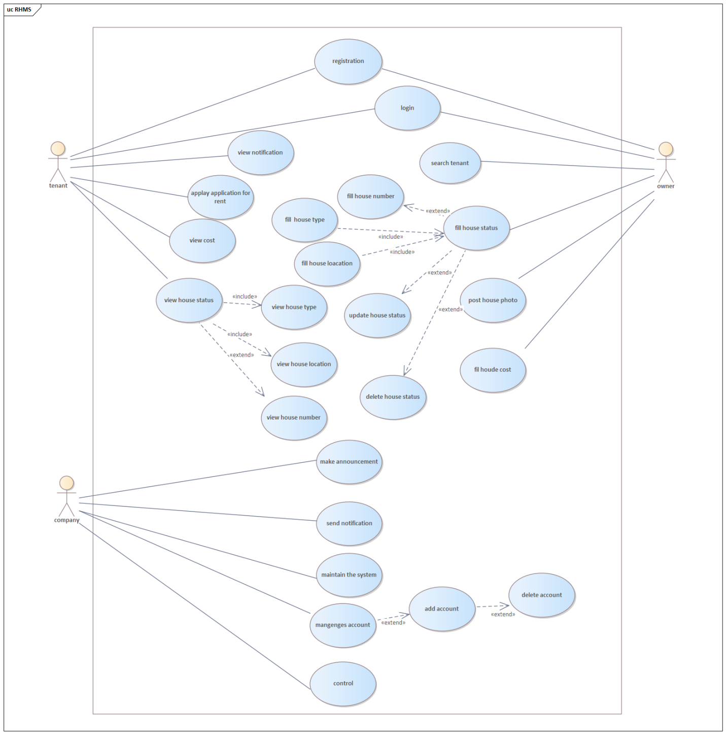
Figure 1 Use case diagram

Use case description
A use case description of means nothing to do. but it is a guideline how users will perform tasks on the website. Each use case is represented as a sequence of simple steps.
Table
Description 1
Use case name | login
Use case id | uc01
Description | Authentication of the system
Participating actors | all users
Precondition | - Internet connection should be available  - Users must have account.
Normal flow | - Users enter in to the website and access the system.  - The system displays the log in page to the user.  - The user enters user name and password to login menu.  - The user clicks login button  - The user will be directed to the system home page.
Post condition | The system will save the information to the data base.
Exceptional flow | If the user enters wrong user name or password the system provides error message to user and again redirect to log in page menu.

Description 2
Use case name | registration
Use case id | uc02
Description | Authentication of the system
Participating actors | all users
Precondition | - Internet connection should be available  - Users must have account.
Normal flow | - User clicks REGISTER button  - Registration form will be displayed  - User fills required and required appropriate information.  - Click NEXT button  - User’s detail displayed at registration page with edit tab.  - If user wants to edit his/her information, then click EDIT tab  - Edit an incorrect information and click SUBMIT button  - Success message will be displayed
Post condition | The system will save the information to the data base.
Exceptional flow | If the user submits unnecessary data, the system displays a message to enter correct data

Description 3
Use case name | Apply rent
Use case id | uc03
Description | If tenants want to find the houses they can apply the application with in the HRMS and then the tenants would select the desired houses as the users of this systems
Participating actors | Tenant
Precondition | - Internet connection should be available  - Users must have account.
Normal flow | - The tenant must be login the system  - The user access the home page `  - The open rent page.  - Click apply rent button  - Fill appropriate application in the boxes  - Click submit button
Post condition | The system will save the information to the data base and the company will view their applications.
Exceptional flow | If the user submits unnecessary data, the system displays a message to enter correct data

Description 4
Use case name | View Notification
Use case id | uc04
Description | If tenants want to find the houses they can apply the application with in the HRMS and then the tenants would select the desired houses as the users of this systems
Participating actors | Tenant
Precondition | - Internet connection should be available  - Users should access the system  - The user must login with valid username and password
Normal flow | - The user first must login  - The user enters in home page  - The users enters notification page  - The user allows notification.
Post condition | The user is fully informed with latest update news
Exceptional flow | If the users disable notifications they are not notified with latest update news

Description 5
Use case name | Fill House Status
Use case id | uc05
Description | House status is filled
Participating actors | House owner
Precondition | - The house owner has the responsibility to correctly fill rent house status to find their desirable tenant.  - The user first must have account and logged into the system
Normal flow | - The user enters in home page menu  - Click fill house status page menu  - The system display fill application box  - Fill status (information) of the house  - Click submit status button
Post condition | The house status is updated
Exceptional flow | If the owner fills misinformation status then the system display “error”, redirect into status page.

Description 6
Use case name | Announce, notify
Use case id | uc06
Description | Notifies and announces the users with latest house information
Participating actors | company
Precondition | - The company will notify and announce the users about their applications.
Normal flow | - The company opens the systems  - Chooses one of announce or notify tab  - The system displays the announcement form  - Chooses target groups or individual  - The company fills the form  - Click PUBLISH button
Post condition | Display announced/notified messages on the users page.
Exceptional flow | .

Description 7
Use case name | Manage account
Use case id | uc07
Description | To delete/approve/view users in to the database
Participating actors | Company
Precondition | - The company will manage the users account
Normal flow | - The user open the system  - Click manage account button  - The system display category to choose  - The user choose target group and choose specific user  - Allows in the user profile and edits if it needed  - Click update button
Post condition | System has successfully delete/update and display account information to the company.
Exceptional flow | When the company fills the form incorrect manner, the message “Invalid data entry” will be displayed.

Description 8
Use case name | Post homes
Use case id | uc08
Description | New home is uploaded to the system
Participating actors | owner
Precondition | - Internet connection should be available  - The user must be logged into the system
Normal flow | - User opens the website.  - The system displays home page menu  - The user clicks the post button.  - The system displays post form.  - The owner fills the post form.  - The owner clicks submit button.
Post condition | New house is uploaded into the system and data will be saved to the database.
Exceptional flow | If the user enters incorrect type of information, the system notifies to validate it

Class Diagram
Class diagram is a type of static structure diagram that describes the structure of a system by showing the system's classes, their attributes, operations (or methods), and the relationships among objects.
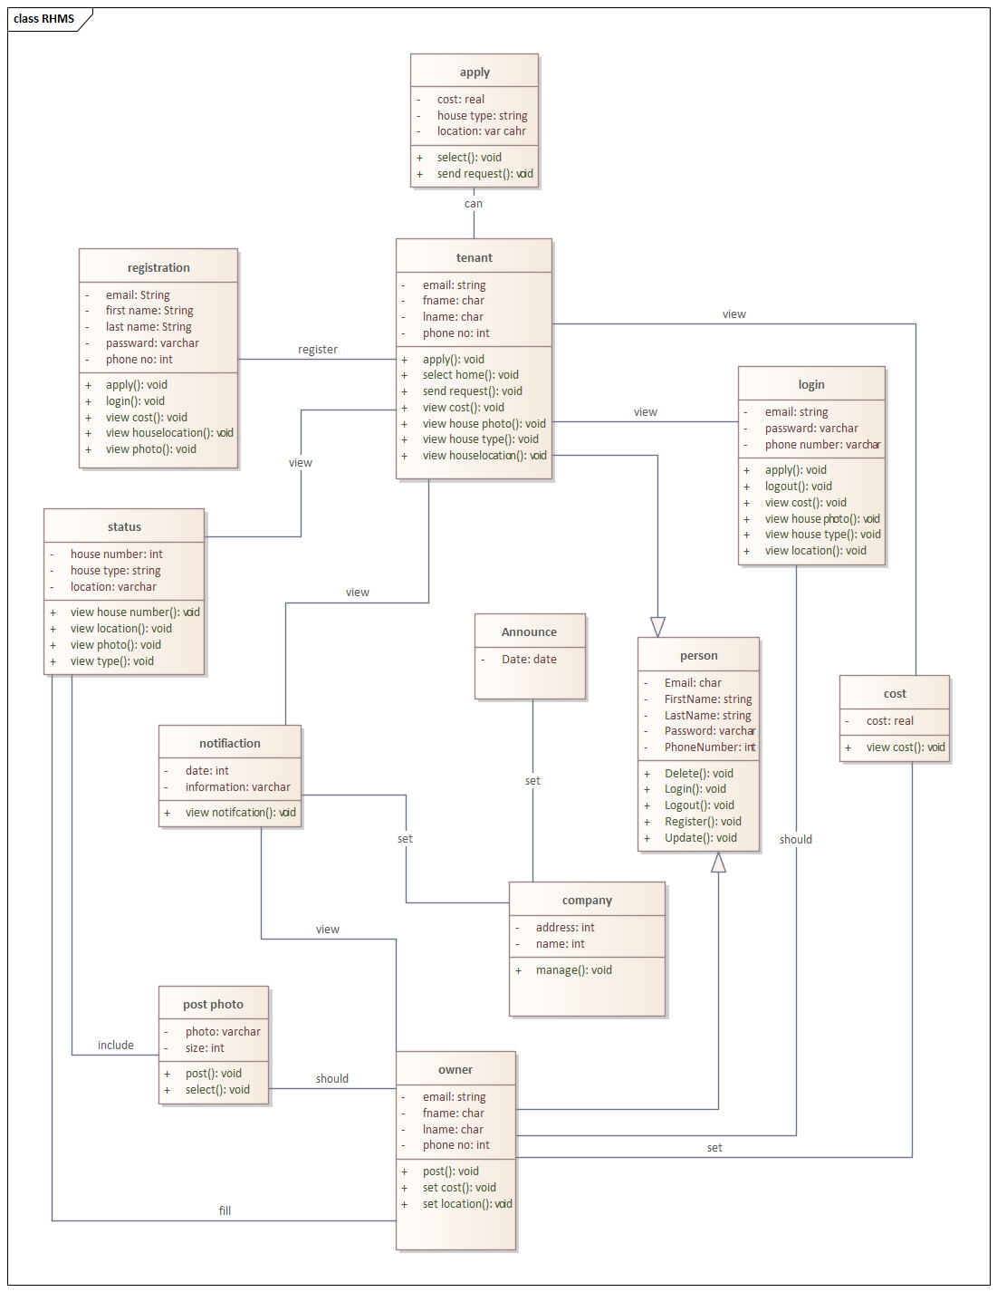
Figure 2 Class Diagram for HRMS

Dynamic Model

Sequence Diagram
Sequence Diagram is an interaction diagram that details how operations are carried out, what messages are sent and when. Sequence diagrams are organized according to time. The time progresses as you go down the page. The objects involved in the operation are listed from left to right according to when they take part in the message sequence.

Below is a sequence diagram for making a RHMS

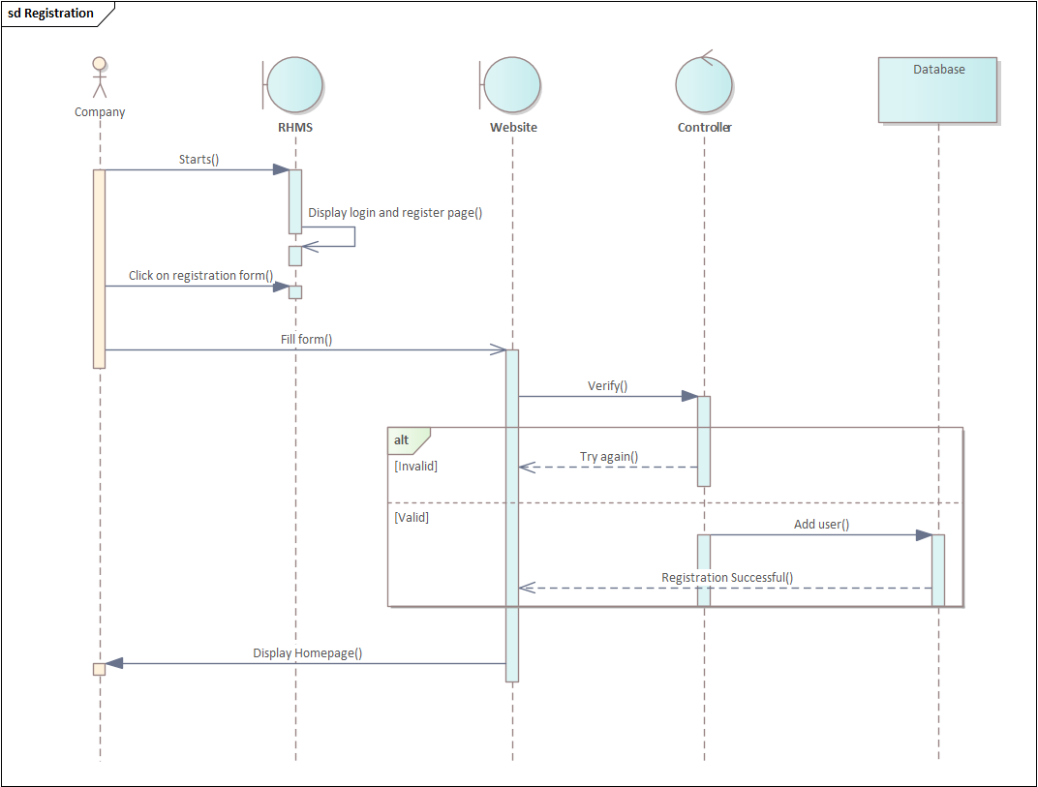
Figure 3 Sequence diagram for Registration
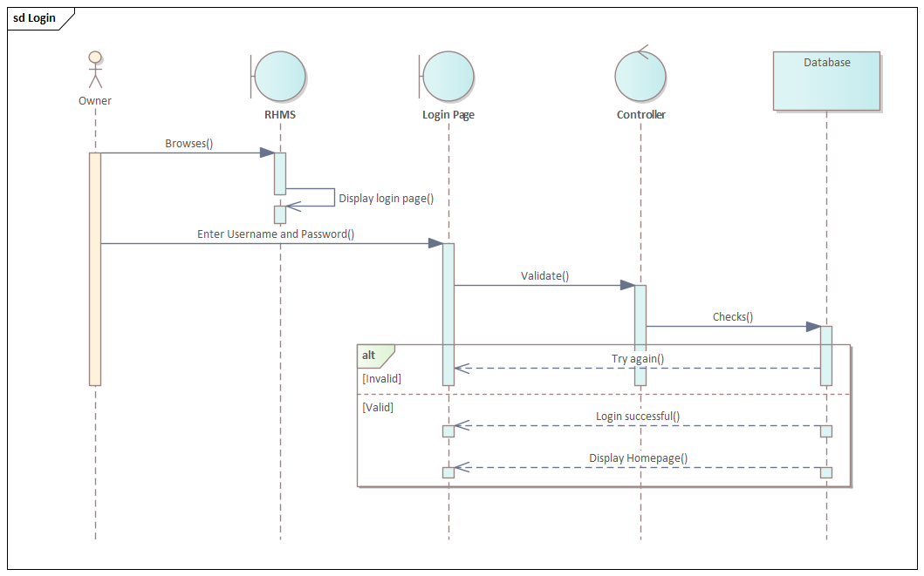
Figure 4 Sequence diagram for Login
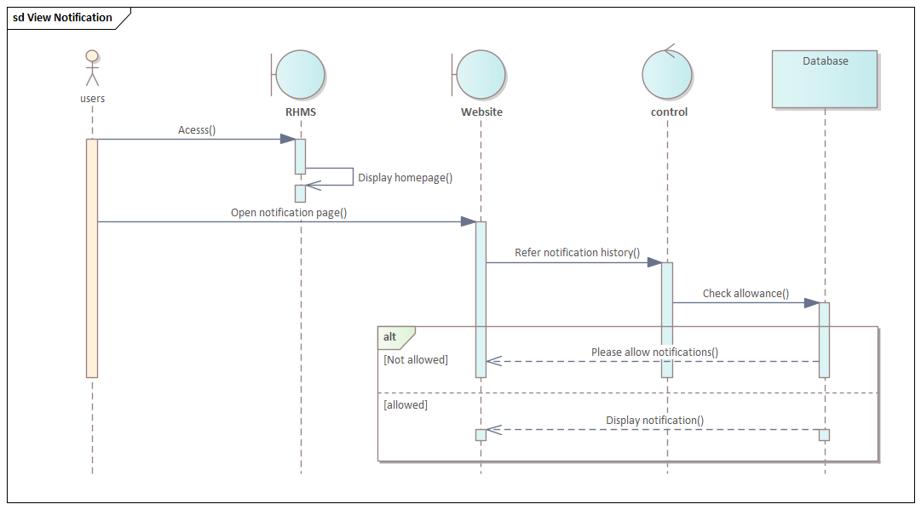
Figure 5 Sequence diagram for View Notification
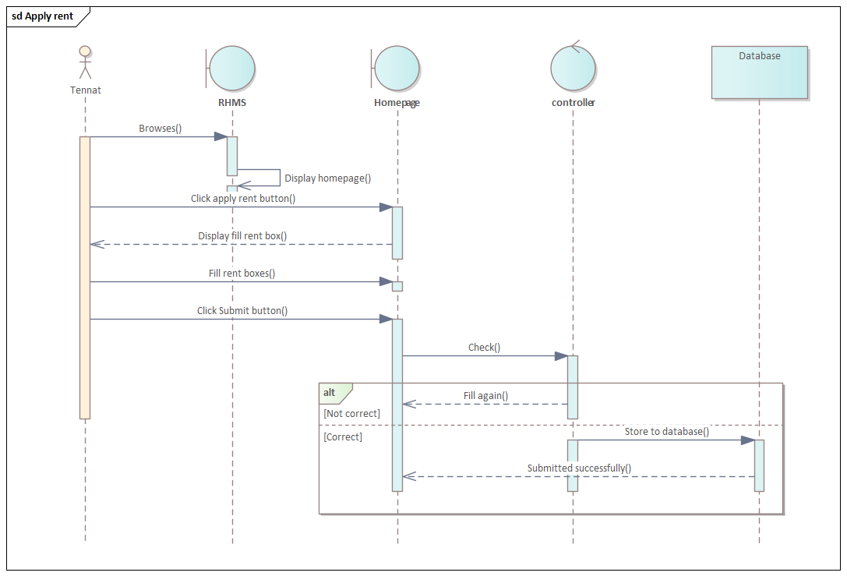
Figure 6 Sequence diagram for Apply rent
Figure 7 Sequence diagram for Fill House Status

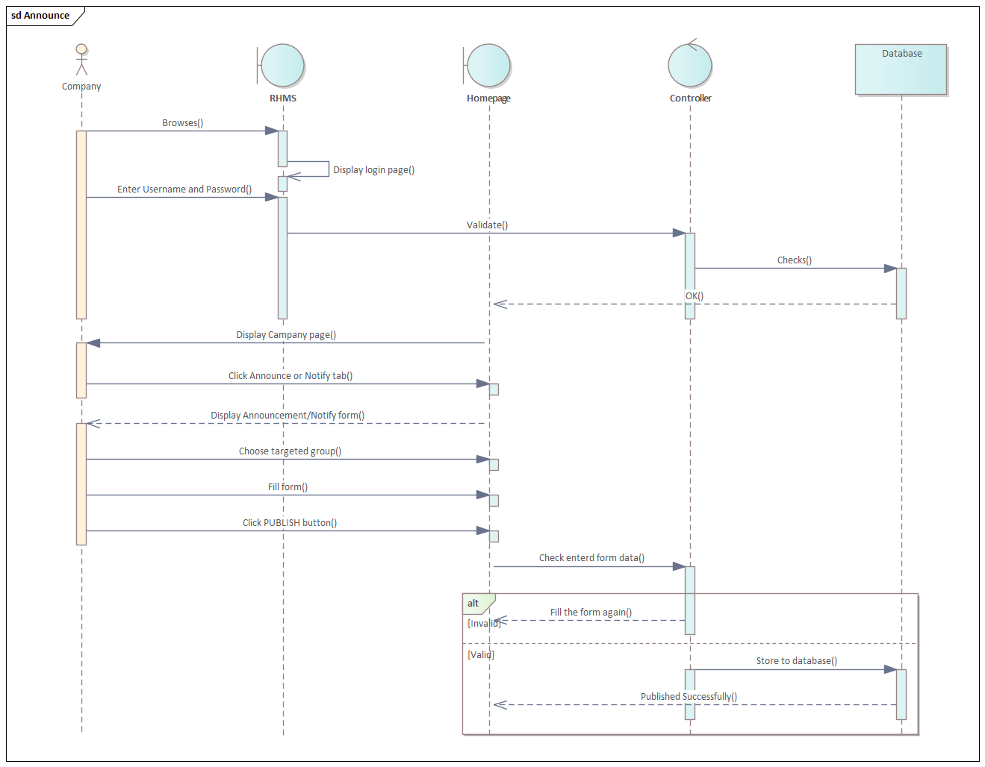
Figure 8 Sequence diagram for Announce
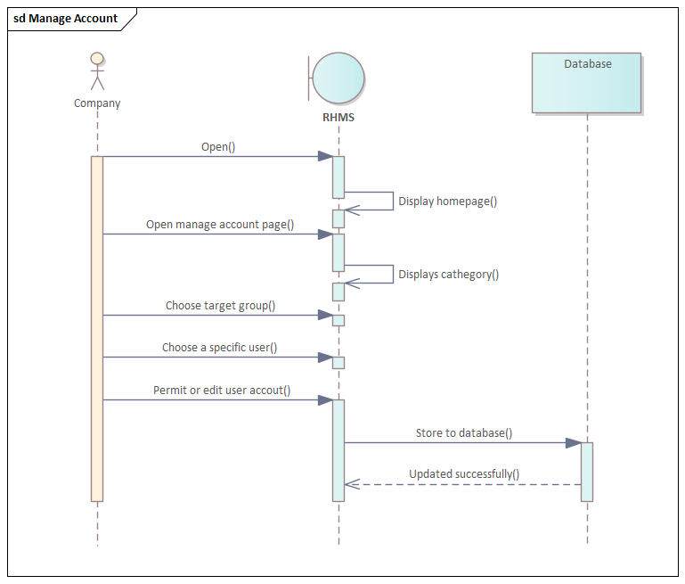
Figure 9 Sequence diagram for Manage Account
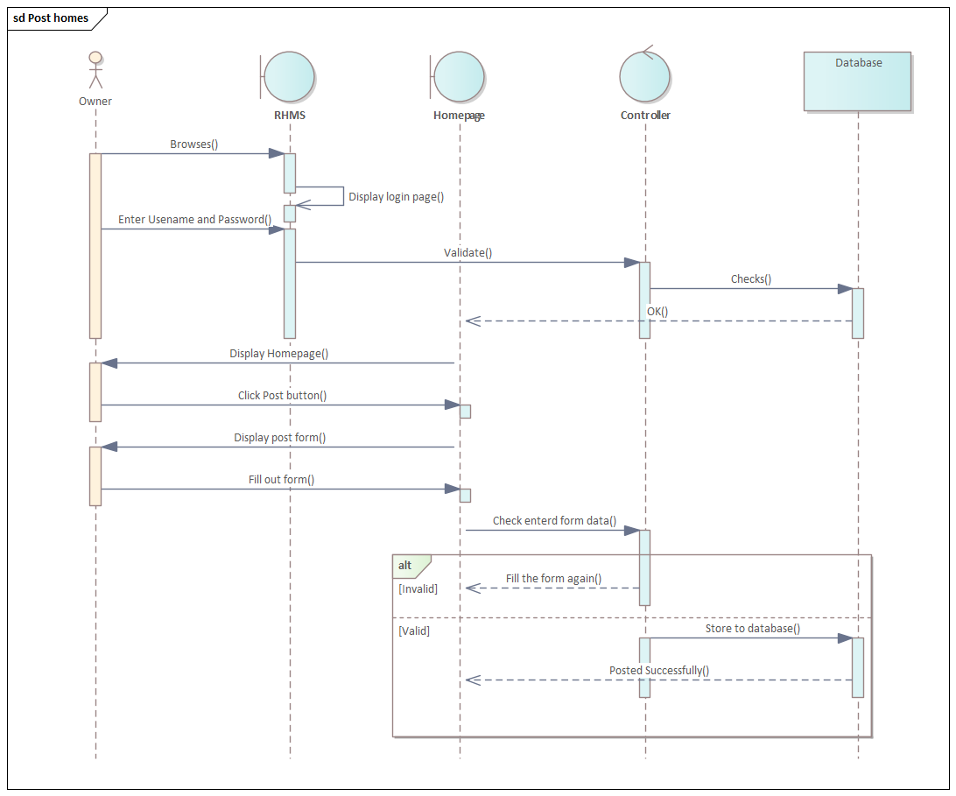
Figure 10 Sequence diagram for Post homes

Activity Diagram
Activity diagram is another behavioral diagram in UML diagram to describe dynamic aspect of the system. It represents a serious of action in a system similar to normal flow or data flow diagram.
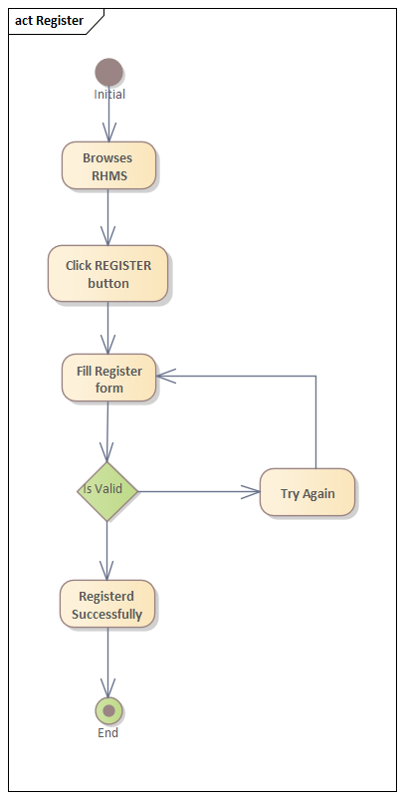
Figure 11 Activity diagram for registration

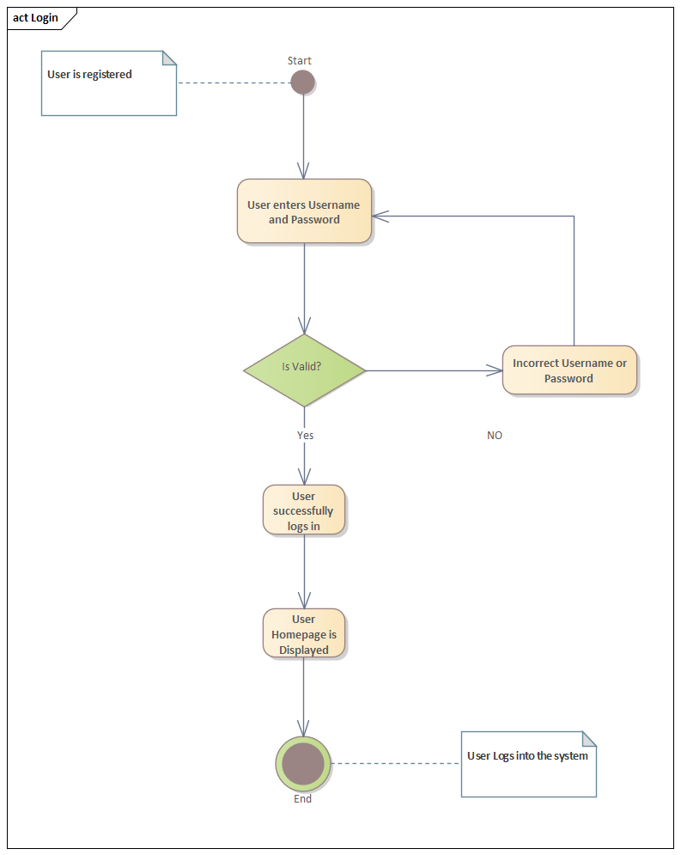
Figure 12 Activity diagram for login
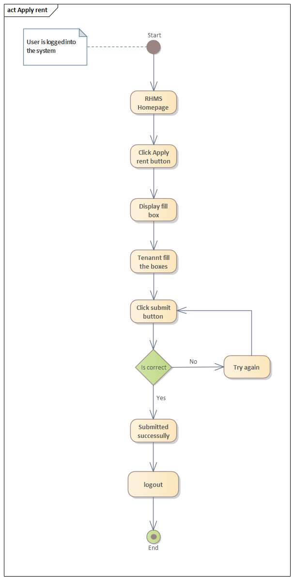
Figure 13 Activity diagram for Apply rent
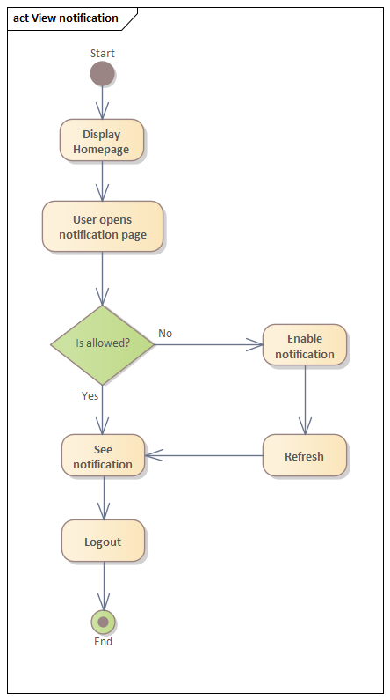
Figure 14 Activity diagram for View notification
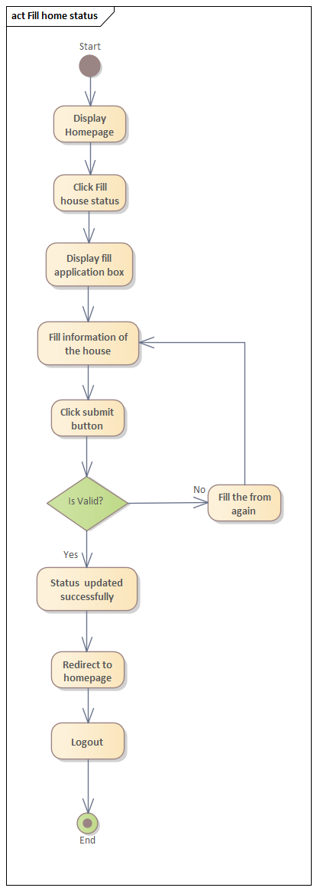
Figure 15Activity diagram for Fill home status
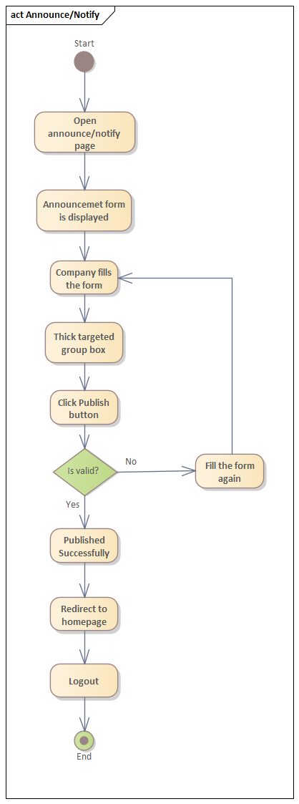
Figure 16 Activity diagram for Announce/Notify

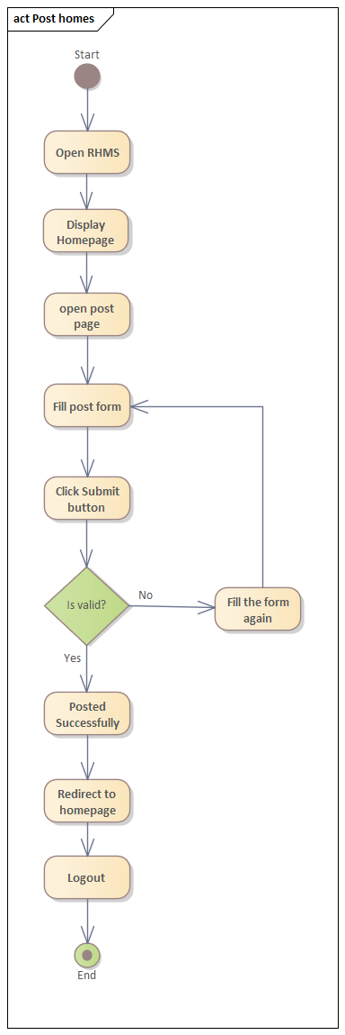
Figure 17 Activity diagram for Post homes

State Diagram

State diagram describes the behavior of a single object in response to a serious of events in a system
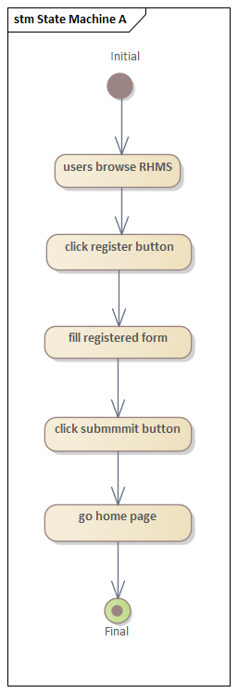
Figure 18 State diagram for Registration
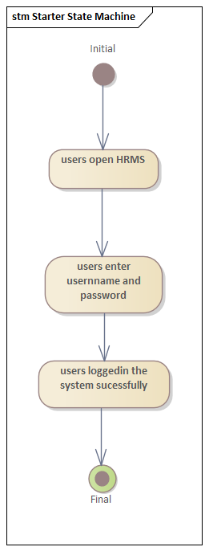
Figure 19 State diagram for Login
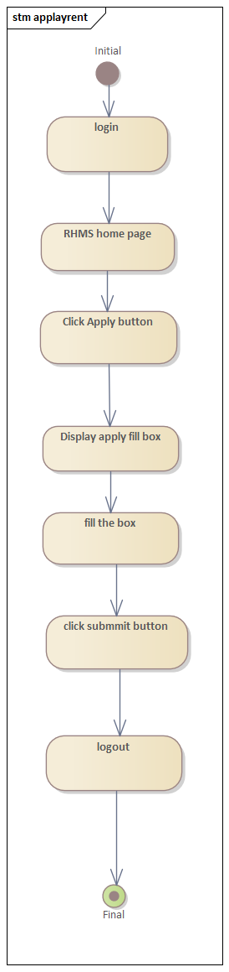
Figure 20 State diagram for Apply rent
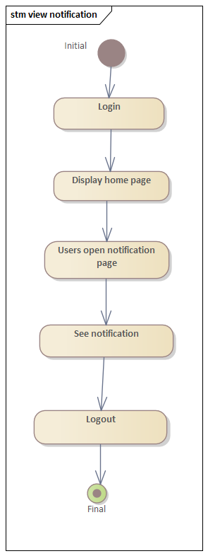
Figure 21 State diagram for View notification
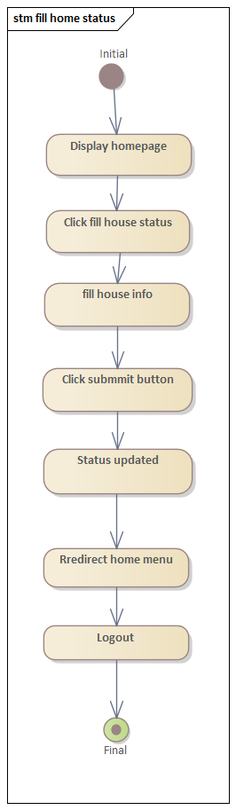
Figure 22 State diagram for Fill home status
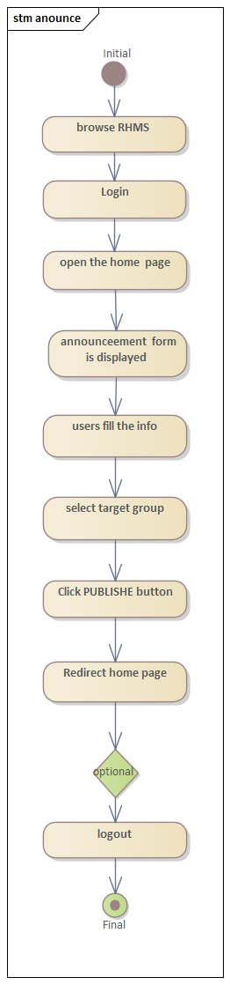
Figure 23 State diagram for Post homes

Chapter Four: System Design

Overview
Systems design is the process of defining elements of a system like modules, architecture, components and their interfaces and data for a system based on the specified requirements. It is the process of defining, developing and designing systems which satisfies the specific needs and requirements of a business or organization. This is the system design document to the Rental Management System for Addis Ababa. The document includes the design goal, the proposed system design and object design.

Purpose of the system
This document describes the design issues of the complete system. It provides the complete
architectural overview of the proposed system. It is intended to capture and express the
important architectural decisions which have been made on the system as well as to obtain the
information needed to manage rental house for Addis Ababa.

Design Goal
The design goals describe the qualities of the system that are derived from the non-functional
requirements which can lead to decisions of developers. The designing part is very important so as to make the implementation or the coding part very easy. The different forms of the system modeling techniques that are used for the implementation of the system such as deployment and component modeling are show in detail. Not only the system modeling techniques but also some system design techniques such as system decomposition design are cover in detail in this phase. These goals can be inferred from the nonfunctional requirements. These are:
- Performance
- Dependability
- Maintenance
- End user
Performance
The system should respond fast with high throughput, i.e. it should perform the task quickly possible as possible such as post property, searching, viewing house status and also apply rent(book property) etc. The system performs its task within a user acceptable time and space. This includes the following:-
- Response time: - depending on the strength of available network the system should be response in short period of time.
- Storage space:-to do work efficiently the processor to be more than 2GB RAM and HD storage to be more than20MB

Proposed system

Overview
The proposed system is mainly centered on the SRS document that’s already submitted. It primarily deals with subsystem decomposition – separating the system into manageable components. Additional main task in system design deals with hardware/software mapping
which deals with which mechanisms would be part in which hardware. Yet additional feature of
system design deals with persistent data management, which illustrate as to how persistent
data (file, database, etc.) are stored and managed and at last Access control will be presented.
Our system is three tires architectural it has client side, server and database.
Client side: here in the client side Tenant, Owners, Administrator, and user interface will be existing.
Server side: here the web servers to unite the data base application are found; mean that the
application logic to perform the application by the client is found
Data base: here the data bases that store the information are found.

Computer Internet Server

RHMS DB

System process
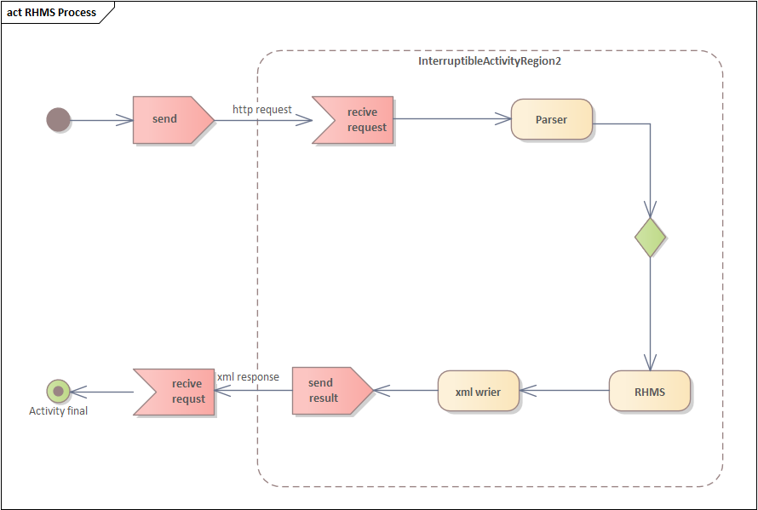
Figure 24 Overall RHMS service
Database
Overall system of the service depicted below
HTTP request HTTP request
Web server
Clint/User
HTTP response HTTP response

Figure 25 Overall system of the service

RHMS system process
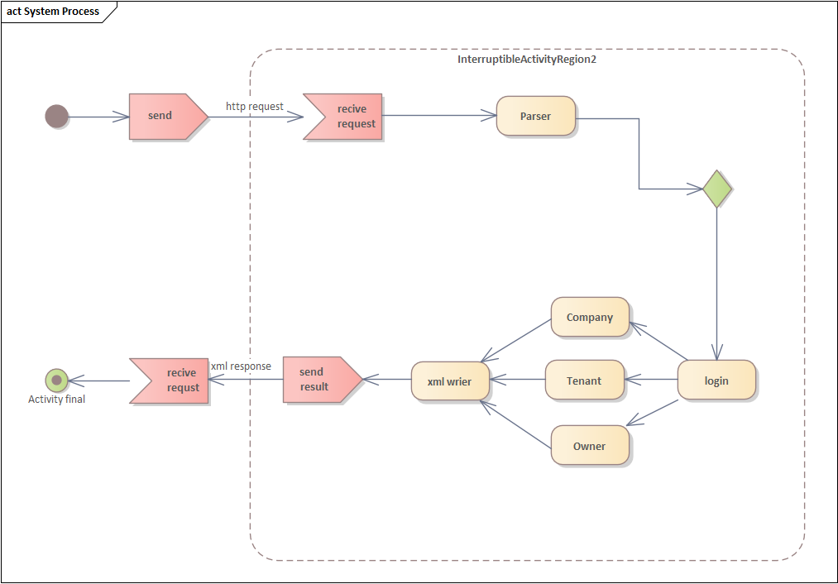
Figure 26 System process

Subsystem decomposition
To lessen the complexity of the solution domain, we decompose a system into simpler parts, called subsystems. The main need of this portion is to design the external part of the system. I this project, there are six subsystem decompositions.
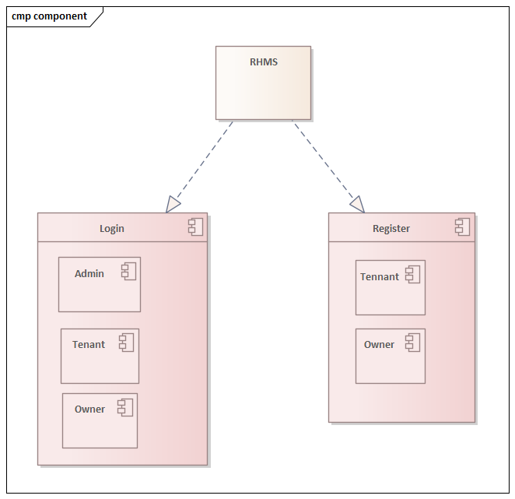
Figure 27 Subsystem decomposition
Subsystem decomposition description
Subsystem | Purpose | Class
Company | Is responsible to manage account and send notification | - Announce  - Notify
Tennant | Is responsible to view notification, search home status and apply rent | - Login  - View coast  - View status  - View notification  - Apply rent
Owner | Is responsible to view notification post home property, | - Login  - Post home  - Fill status  - View notification

Hardware and software mapping
When we say hardware/software mapping for the system, it defines how subsystems
are allocated to hardware and off-the-shelf components. In this system design mainly there are
three hardware components, the client side, web/application server and data server. Network
should be installed between each side.
Login
Register
View House

Client

RHMS Database

Persistent data management
The target of this section is to display the mapping of the objects/classes of the system, determined through the analysis stage, in to the corresponding relational database
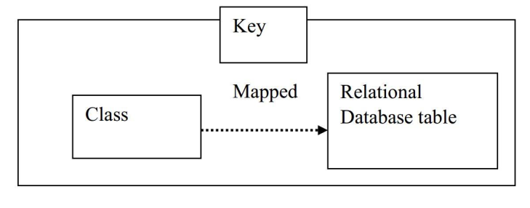
Figure 28 Class to relational database mapping
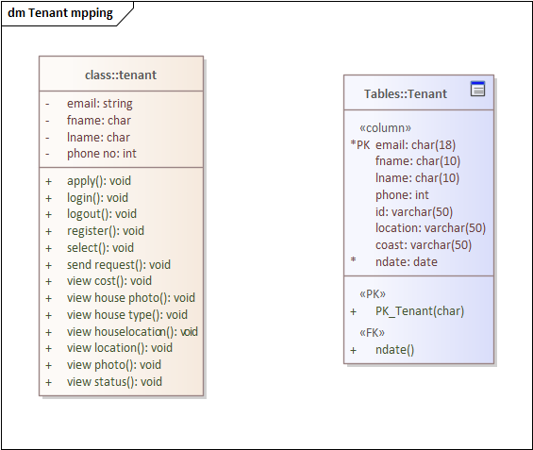
Figure 29 Tennant mapping
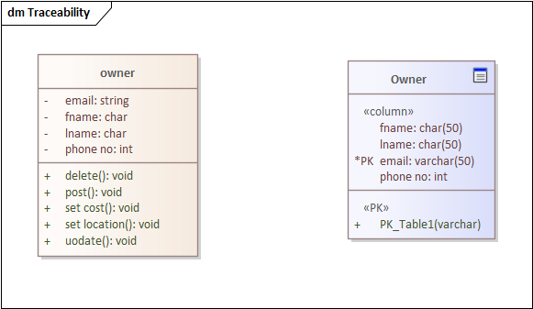
Figure 30 Owner mapping
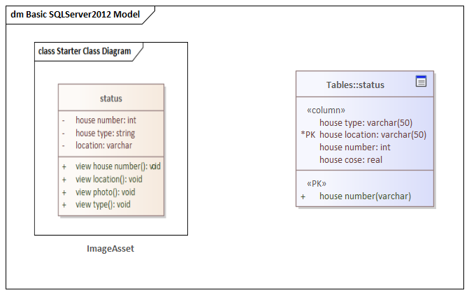
Figure 31 Status mapping
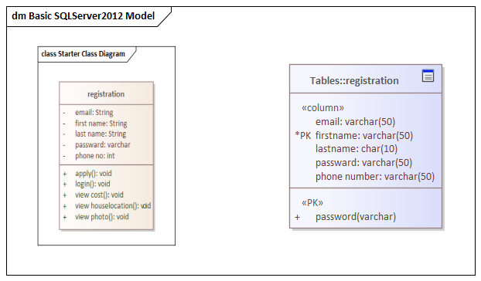
Figure 32 Register mapping
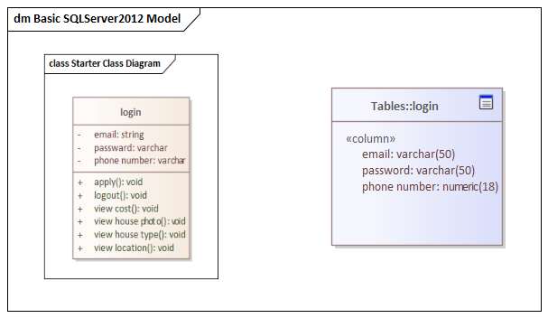
Figure 33 Login mapping
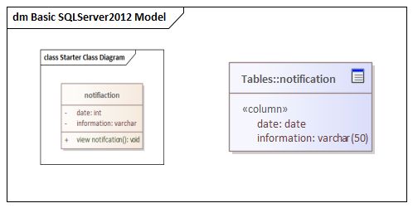
Figure 34 Notification mapping
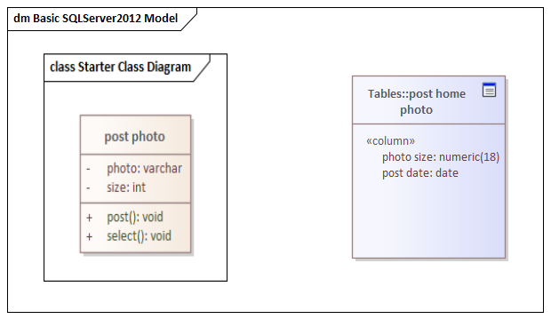
Figure 35 Post mapping
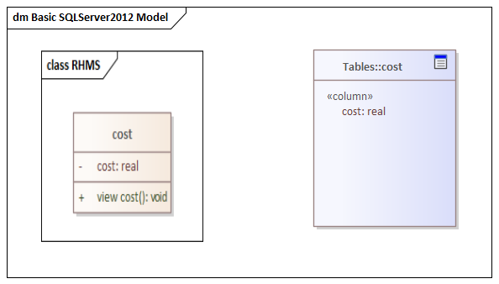
Figure 36 Coast mapping
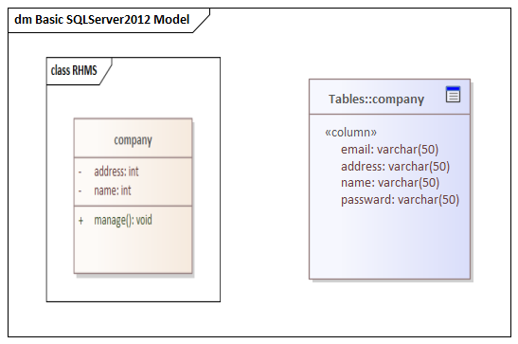
Figure 37 Company mapping
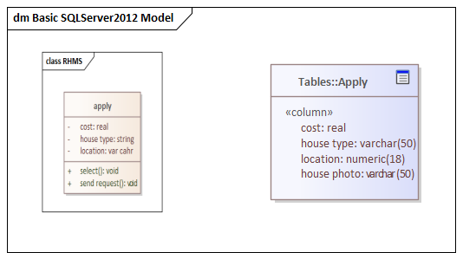
Figure 38 Apply mapping

Component Diagram
The next component diagram signifies a set of graphs of components associated by
dependency relations and dependencies are displayed as dashed arrows from the client
component to the supplier component
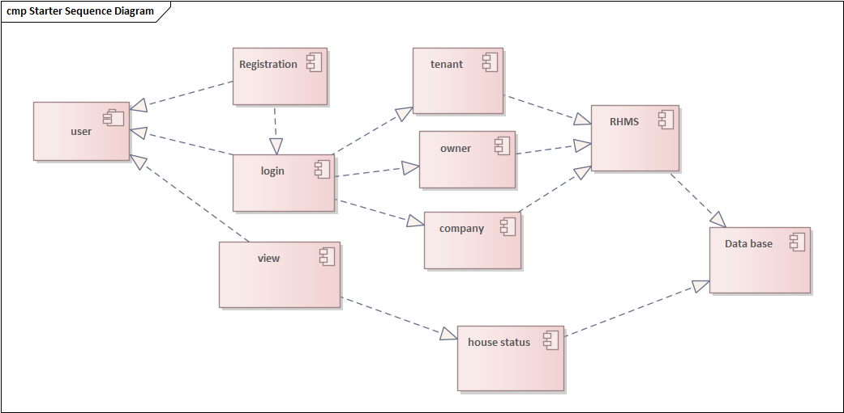
Figure 39 Component diagram for RHMS

Deployment Diagram
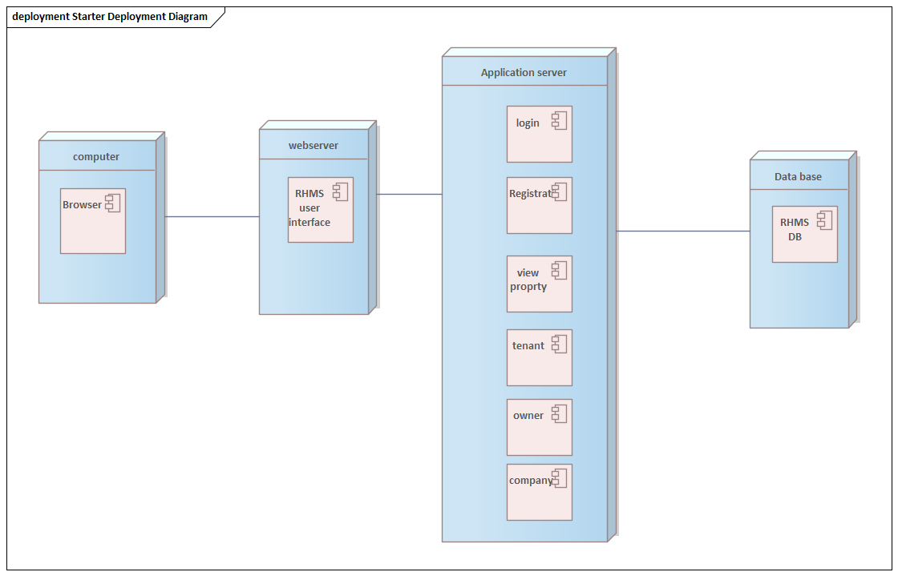
Figure 40 Deployment diagram for RHMS

Database design
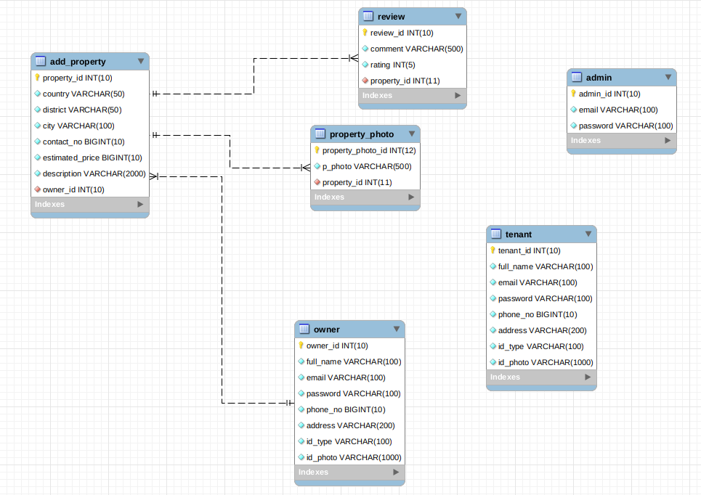

User interface design
Figure 41 User interface design of RHMS
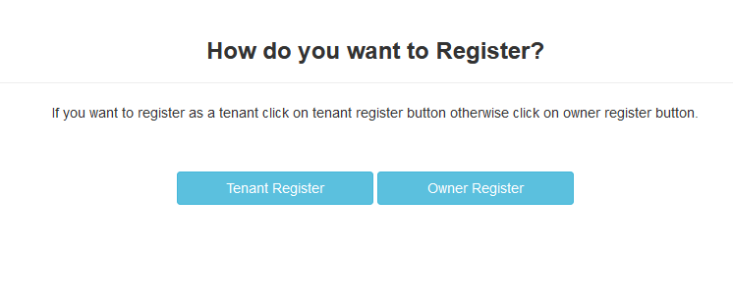
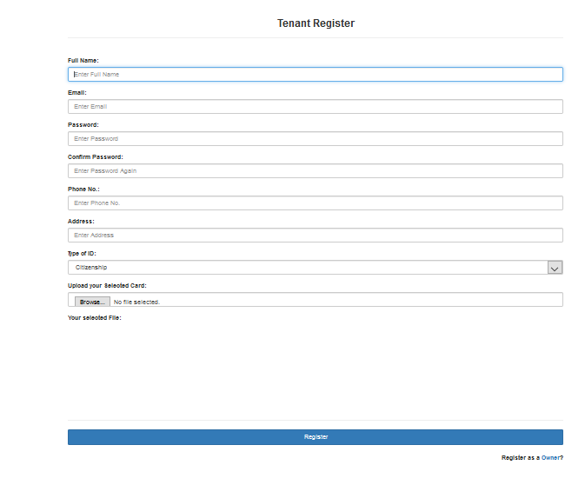
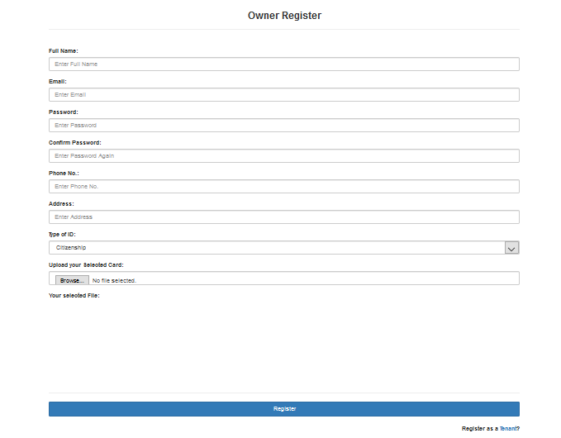
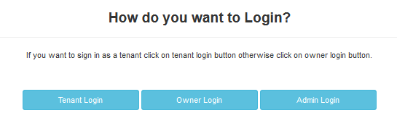
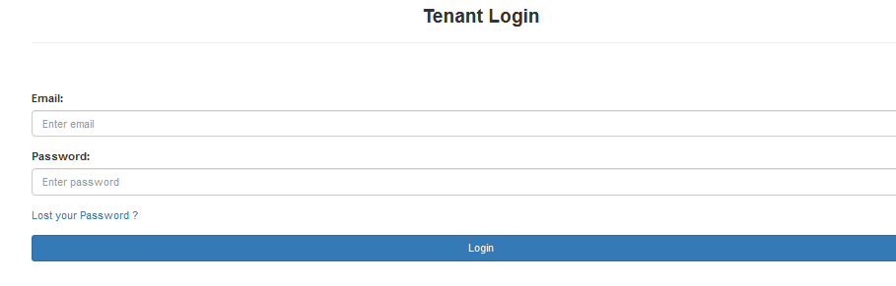
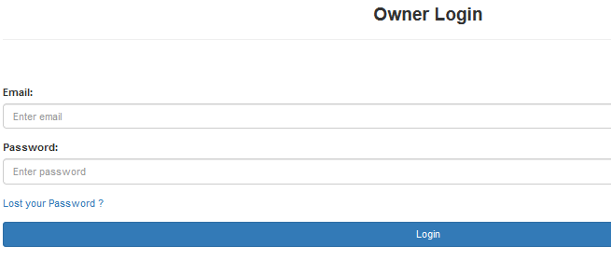

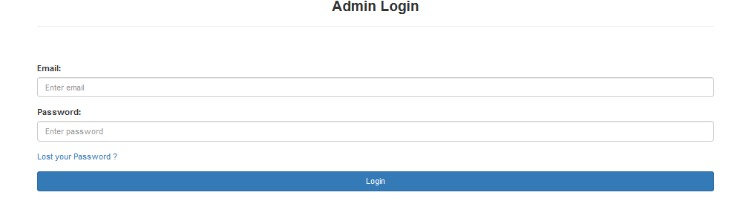

Reference
      - Erguden, S. (2001), Low cost housing policies and constraints in developing countries, International conference on spatial development for sustainable development, Nairobi.
      - Seedhouse, D. (1986), Foundation for Health Achievement, Health Policy, vol. 7, issue, 3.
      - United Nations, (1948), The Bill of Human Rights
      - https://www.modishproject.com/

